LINE INTEGRALS AND ELECTRO-MOTIVE FORCE
Syed Sualeh Abbas | Syed Ali Hussain Zaidi
ABSTRACT:
In the literature of electro-dynamics, Electro-Motive Force (EMF) is known as the work done per unit charge which flows around the circuit. EMF and Line integrals play crucial role in engineering mathematics, specially in circuit theory and electromagnetics.
INTRODUCTION:
Electromotive Force is defined as the circulation of Electric Field around a closed path. In easy words, force per unit charge, that a charge experience when travelling around a closed path. Fraday’s Law is the fundamental electromagnetic law that expresses EMF as a line integral of electric field around a closed loop.
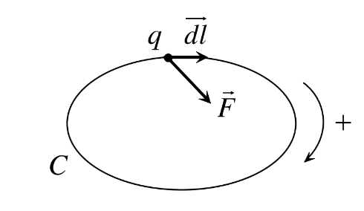
Faraday’s Law is given by:
$$ε=\oint_{C}{E.dl}$$
Where:
- $ε=$ Electromotive Force (EMF)
- $E=$ Electric Field
- $dl=$ vector representing a tiny piece of the path $C$
Mathematical Background:
Line Integrals:
A line integral is a way of summing a vector field along a path or curve. In physics, it is used to calculate quantities like work done by a force along a path or the electromotive force along a conductor.
Mathematically, if $F$is a vector field and $C$is a path, the line integral is:
$$\int_{C}{F⋅dl}$$
In electromagnetism, the line integral of the electric field around a closed loop defines the induced EMF:
$$E=\oint_{C}{E⋅dl}$$

Lorentz Force:
The Lorentz force describes the force experienced by a charge $q$moving in electric and magnetic fields:
$$F=q(E+v×B)$$
For a purely magnetic field, this reduces to $F=q(v×B)$. This force causes free charges in a moving conductor to move, creating a current, which is the basis for motional EMF.
Electromotive Force:
EMF is the work done per unit charge to move it around a closed circuit. It can be induced by changing magnetic flux (Faraday’s law) or by motion in a magnetic field (motional EMF).
Faraday’s law (for a moving conductor or changing flux):
$$E=\oint_{C}{E⋅dl=-}\frac{dΦ}{dt}$$
Here, $Φ$ is the magnetic flux through the loop. Physically, EMF drives a current that opposes the change in flux (Lenz’s law).
Model Development:
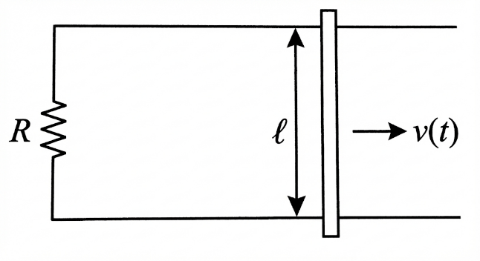
Consider two long, straight, parallel conducting rails separated by distance ℓ, lying in a horizontal plane. A conducting rod of length ℓ bridges the rails and can slide frictionlessly along them (see Figure. 1). A uniform magnetic field B is applied perpendicular to the plane of the rails (e.g. pointing into the page). The rod is free to move horizontally at speed v(t). We assume the rails and rod form a closed circuit by a resistor R at one end, so current can flow.
Figure 1
Key Assumptions:
- There is a constant magnetic field (B)
- The rod slides without any friction and breaking any electrical contact
- The circuit have no resistance, except the lumped resistor
- Motion transverse to B so, $v, l, B$ are mutually perpendicular

Let x(t) be the horizontal position of the rod along the rails. Then, the area of the loop at time t is:
$$A\left(t\right)=l.x(t)$$
The magnetic flux through this loop is the product of the magnetic field B (assumed uniform and perpendicular to the plane of the loop) and the loop area:
$$Φ\left(t\right)=B.A\left(t\right)=B.l.x(t)$$From Faraday’s Law, the induced EMF (magnitude) in the loop is:
$ε=\left|\frac{dΦ}{dt}\right|=\left|\frac{d}{dt}(Blx)\right|=Blv$,
since $x\left(t\right)$is the rod’s horizontal position and $v=dx/dt$. Equivalently, one can view the rod as a “battery” of EMF $Blv$produced by the magnetic Lorentz force F = q(v×B) on the free charges in the moving rod. When the loop is closed through resistance R, the induced EMF drives a current I given by Ohm’s law ($V=IR, where V=ε)$:
$$I=\frac{E}{R} = \frac{Blv}{R}$$
The rod carries current I upward (from the lower rail to the upper rail, as determined by Lenz’s rule). In the uniform B field into the page, the magnetic force on the rod is:
$$F=I(l x B)$$
Thus, the Force magnitude becomes:
$$F_{mag}=-IlB=-\frac{B^{2}l^{2}}{R}v$$
This magnetic drag is the only horizontal force acting on the rod, since we assumed no negligible friction. From newtons second law of motion (i.e. F = m.a) we get;
$$m\frac{dv}{dt}=-\frac{B^{2}l^{2}}{R}v+F_{ext}(t)$$
where $F_{\text{ext}}$represents any external push or gravity component.

SOLVING THE MODEL:
Assumptions:
- CASE I: No external force: $F_{\text{ext}}=0.$
- CASE II: Constant applied Force: $F_{\text{ext}}=F_{0}$

CASE I:
Separate variables or recognize standard form:
$$\frac{dv}{v}=-\frac{B^{2}l^{2}}{mR}dt$$
Integrate on both sides:
$$ln⁡v=-\frac{B^{2}l^{2}}{mR}t+C$$
Exponentiating both sides:
$$v\left(t\right)=v_{0} e^{-\frac{t}{τ}}, τ=\frac{mR}{B^{2}l^{2}}$$
The rod’s speed decays exponentially due to magnetic braking. As the speed decreases, the EMF and current also decay:
$$E\left(t\right)=Blv\left(t\right), I(t)=\frac{Blv(t)}{R}$$
Eventually, $v→0$as $t→∞$, the rod stops. Energy perspective: The rod’s initial kinetic energy is converted entirely into Joule heating in the resistor:
$$P_{mech}=F_{mag}v=I^{2}R$$CASE II:
If an external force $F_{0 }$is applied:
$$m\frac{dv}{dt}=F_{0}+F_{mag}=F_{0}+\left(-\frac{B^{2}l^{2}}{R}v\right)$$
This is again a first-order linear ODE, but now with a constant source term.
Steady-State:
At long times ($\frac{dv}{dt}=0$):
$$F_{0}=\frac{B^{2}l^{2}}{R}v_{term}⇒v_{term}=\frac{F_{0}R}{B^{2}l^{2}}$$
The rod moves at a constant velocity where the external force balances the magnetic drag. The solution is an exponential approach to this terminal velocity. If $F_{0}$were exactly zero, the analysis reverts to case I.

INTERPRETATION OF RESULTS:
This model connects back to line integrals as the induced EMF equals the line integral $∫\left(v×B\right)⋅dl$along the rod, which in our simple geometry reduces to $Blv$. In more general terms, Faraday’s law states $∮E.dl=-\frac{dΦ}{dt}$ for any moving loop. Here, the changing flux is purely due to the moving boundary. Our result $E=Blv$demonstrates how a line integral produces the same EMF as the flux rule.
APPLICATIONS:
- Electric generators: Convert mechanical motion into electrical energy using changing magnetic flux.
- Railguns: Accelerate projectiles by induced currents in a sliding conductor.
- Induction braking: Slow down moving vehicles using magnetic drag without contact.
- Metal detectors: Detect metals by measuring EMF induced in moving coils.
- Electric meters: Measure current or voltage using a moving coil in a magnetic field.
CONCLUSION:
We modeled a rod sliding on rails in a constant magnetic field; a standard illustration of motional EMF. The EMF around the loop is given by changing flux in loop and the induced current that yields a magnetic force opposing the motion. By making clear assumptions we obtained a simple analytical solution: an exponentially decaying velocity when no external force is applied. This exercise highlights the interplay of vector calculus with physical laws of electromagnetism, and it illustrates energy conversion from mechanical to electrical form. Such a model underlies real devices like rail guns or generators, where mechanical motion in a magnetic field creates EMF.
REFRENCES:
- “Line integral,” Wikipedia, Link, accessed Dec. 7th, 2025.
- “Electromotive force,” Wikipedia, Link, accessed Dec. 7th, 2025.
- “Motional Emf,” Department of Electrical & Computer Engineering, University of Illinois at Urbana–Champaign, Link, accessed Dec. 7th, 2025.
- “Faraday’s law of induction,” Grokipedia, Link, accessed Dec. 7th, 2025.
- “Faraday’s law of induction,” Wikipedia, Link, accessed Dec. 7nd , 2025.
- “Magnetic Flux, Induction and Faraday’s Law,” Boundless Physics (LibreTexts), Link, accessed Dec. 7th, 2025.

